**Chapter 2: Lab Accessing the Command Line**

Marko Shaffer

Information Technology, Franklin University

ITEC 200: Linux Fundamentals

Professor Kagan Ulucay

5/28/2023

Red Hat System Administration I 8.2

Chapter 2 - Lab Accessing the Command Line

**Performance Checklist:**

In this lab, you will use the Bash shell to execute commands.

**Outcomes:**

* Successfully run simple programs using the Bash shell command line.
* Execute commands used to identify file types and display parts of text files.
* Practice using some Bash command history "shortcuts" to more efficiently repeat commands or parts of commands.

Log in to the workstation as username student using student as the password.

|  |  |  |  |
| --- | --- | --- | --- |
|  | Franklin VM: | Standard User Account: | The Student's Root Account: |
| Username | kiosk | student | root |
| Password | redhat | student | redhat |

On the workstation, run the **lab cli-review start** script to set up a clean lab environment. The script also copies the zcat file to the student's home directory.

**[student@workstation ~]$ lab cli-review start**

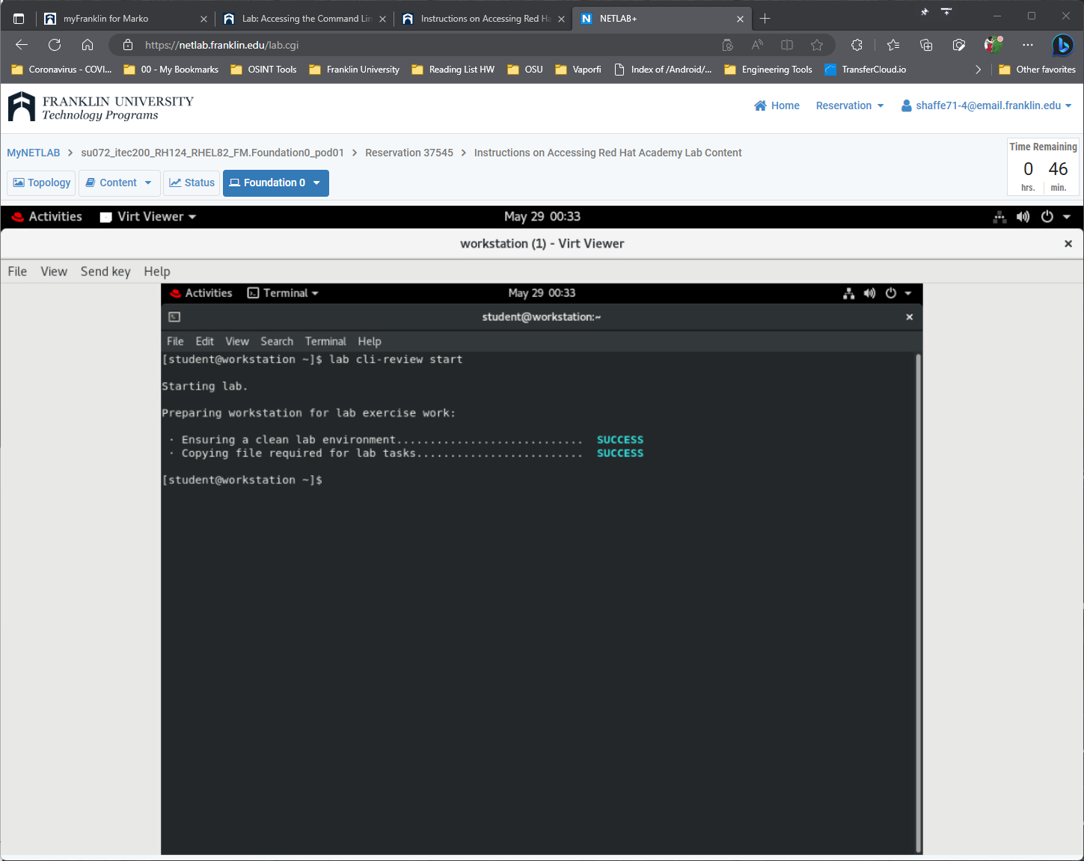

1. Use the **date** command to display the current time and date.

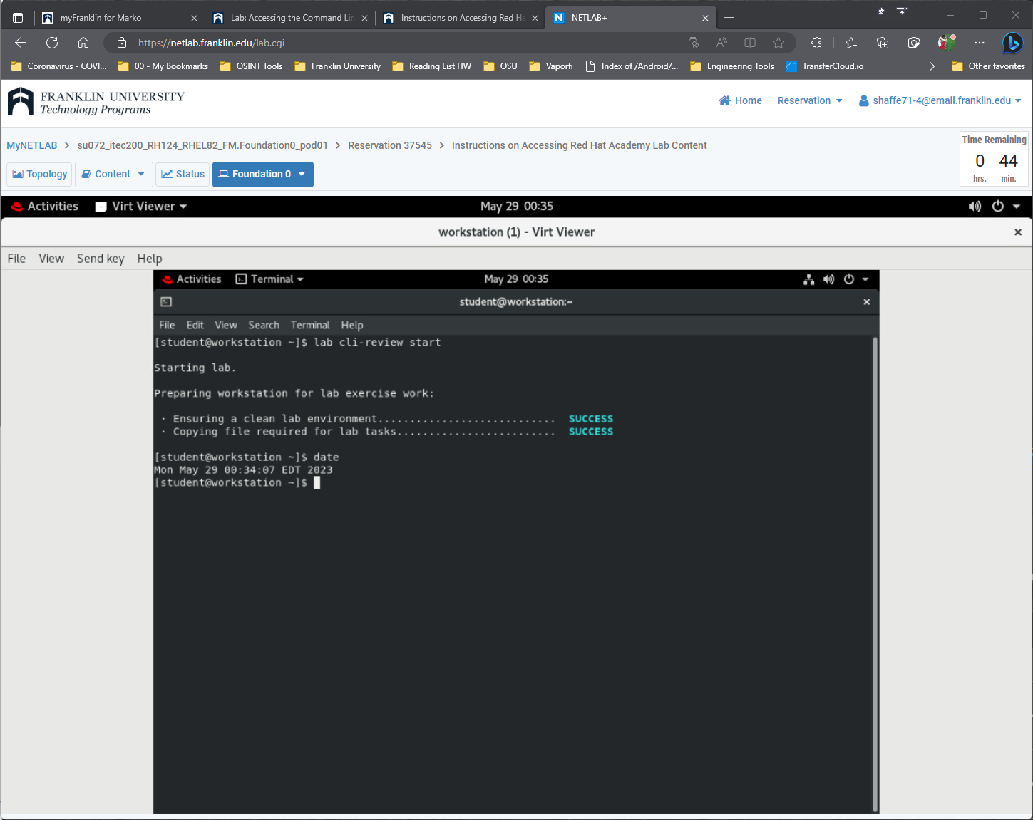

1. Display the current time in 12-hour clock time (for example, 11:42:11 AM). Hint: The format string that displays that output is %r.

Use the +%r argument with the **date** command to display the current time in 12-hour clock time.

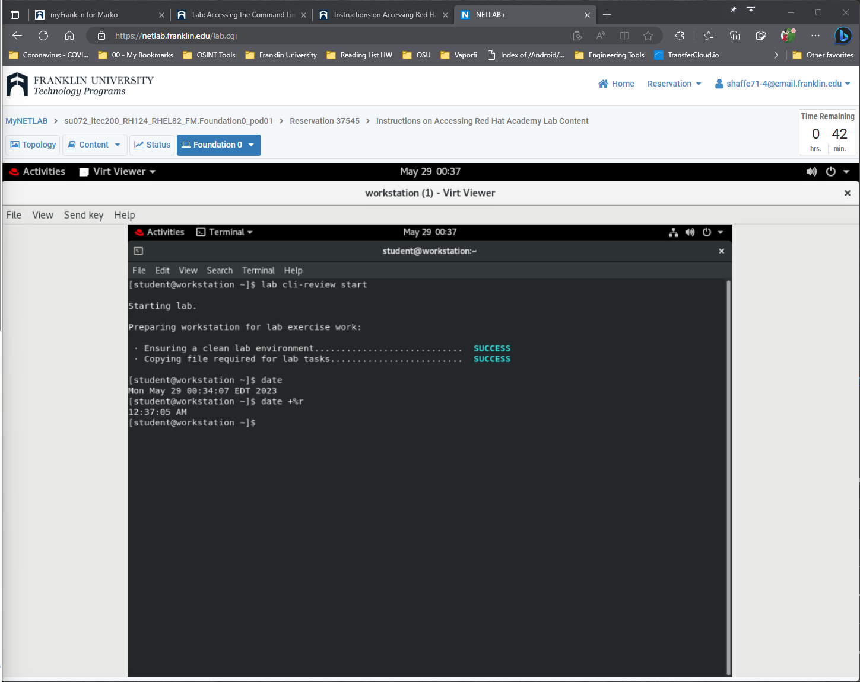

1. What kind of file is /home/student/zcat? Is it readable by humans?

Use the **file** command to determine its file type.

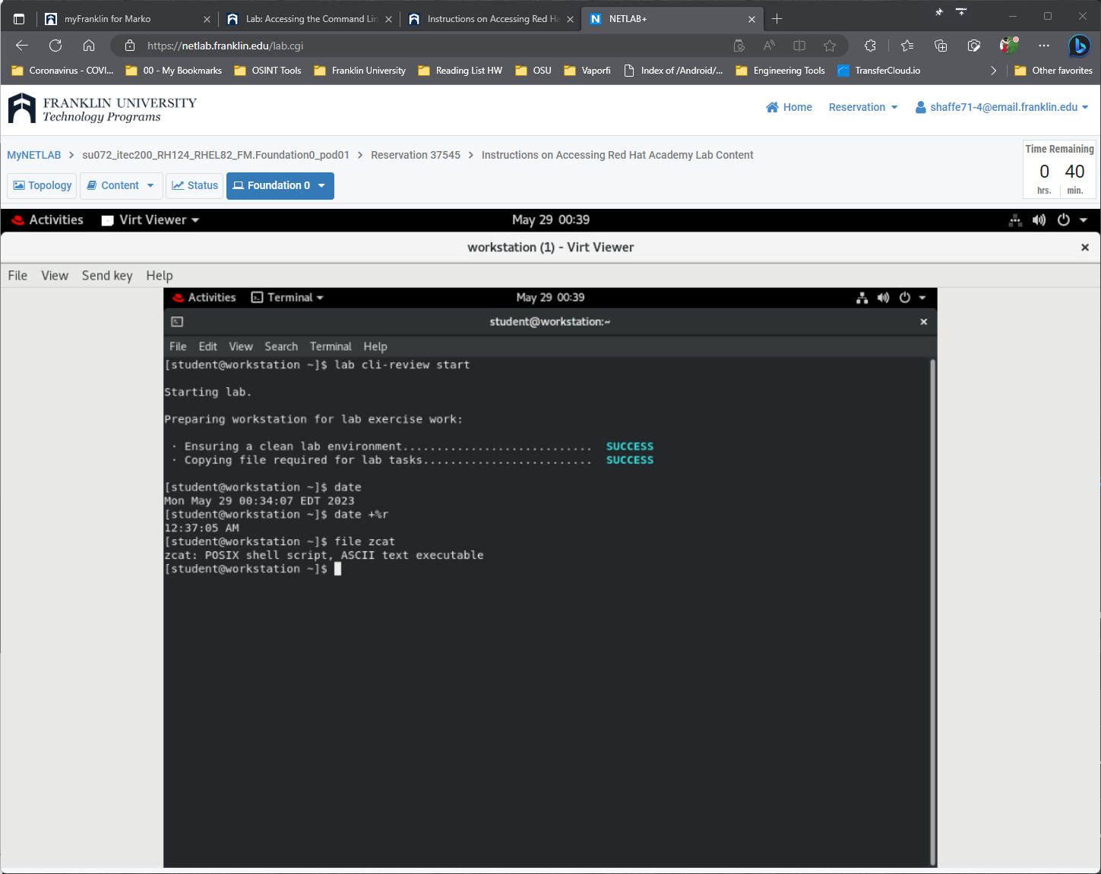

1. Use the **wc** command and Bash shortcuts to display the size of zcat.

The **wc** command can be used to display the number of lines, words, and bytes in the zcat script. Instead of retyping the file name, use the Bash history shortcut **Esc**+**.** (the keys **Esc** and **.** pressed at the same time) to reuse the argument from the previous command.

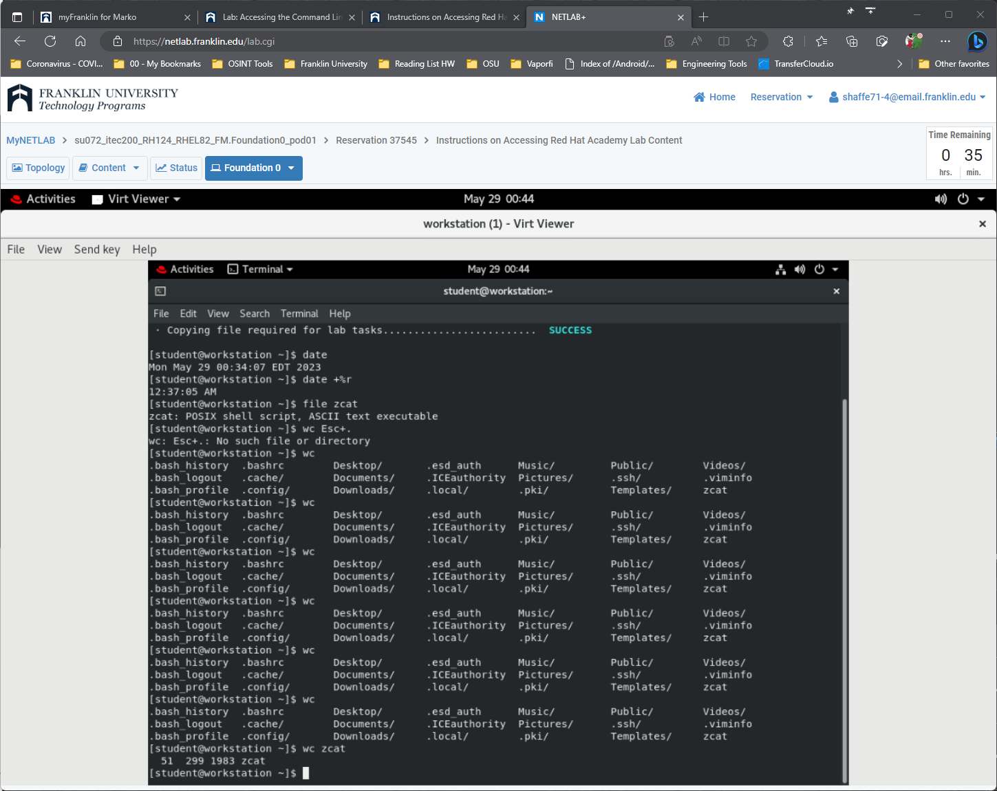

1. Display the first 10 lines of zcat.

The **head** command displays the beginning of the file. Try using the **Esc**+**.** shortcut again.

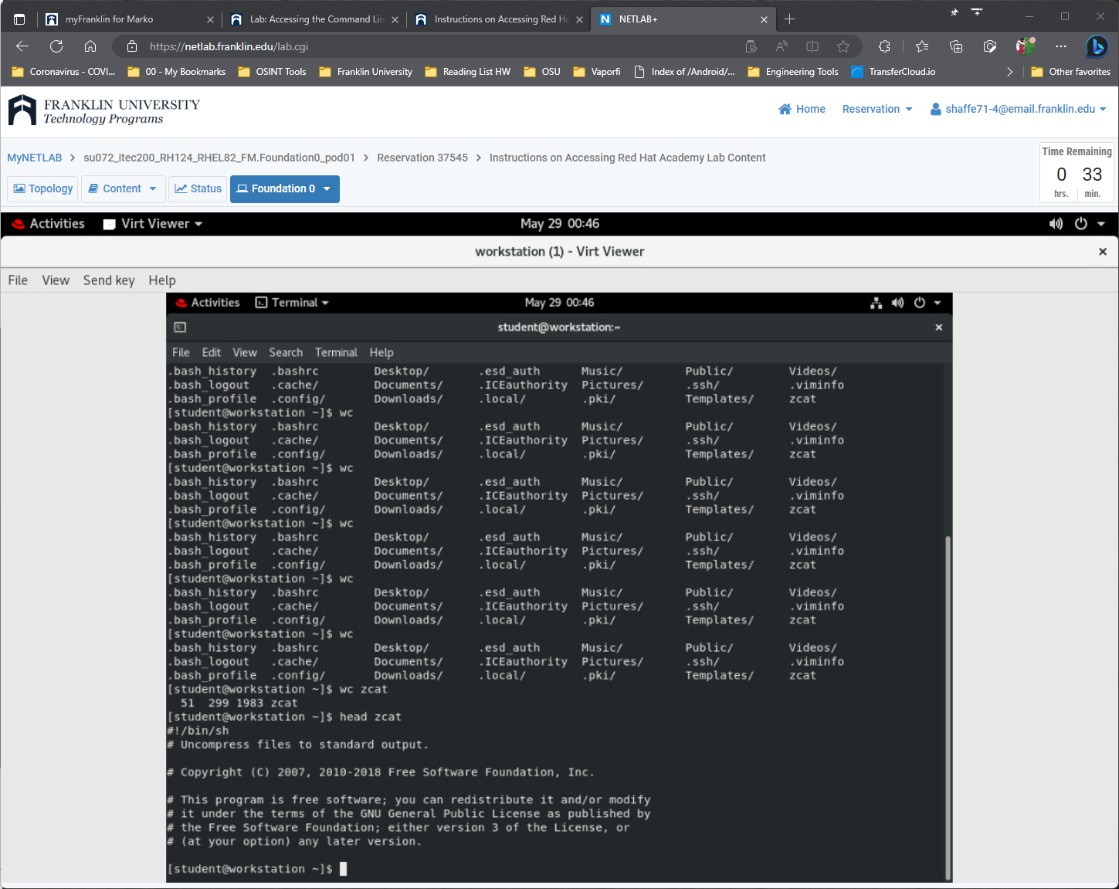

1. Display the last 10 lines of the zcat file.

Use the **tail** command to display the last 10 lines of the zcat file.

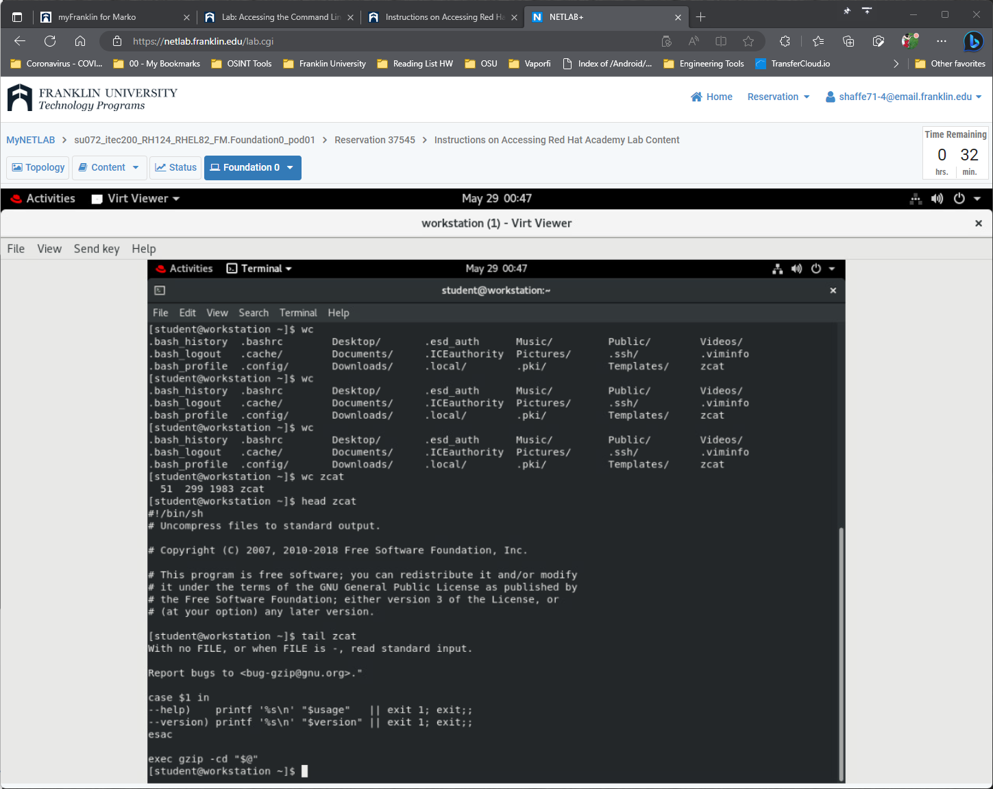

1. Repeat the previous command exactly with three or fewer keystrokes.

Repeat the previous command exactly. Either press the **UpArrow** key once to scroll back through the command history one command and then press **Enter** (uses two keystrokes), or enter the shortcut command **!!** and then press **Enter** (uses three keystrokes) to run the most recent command in the command history . (Try both.)

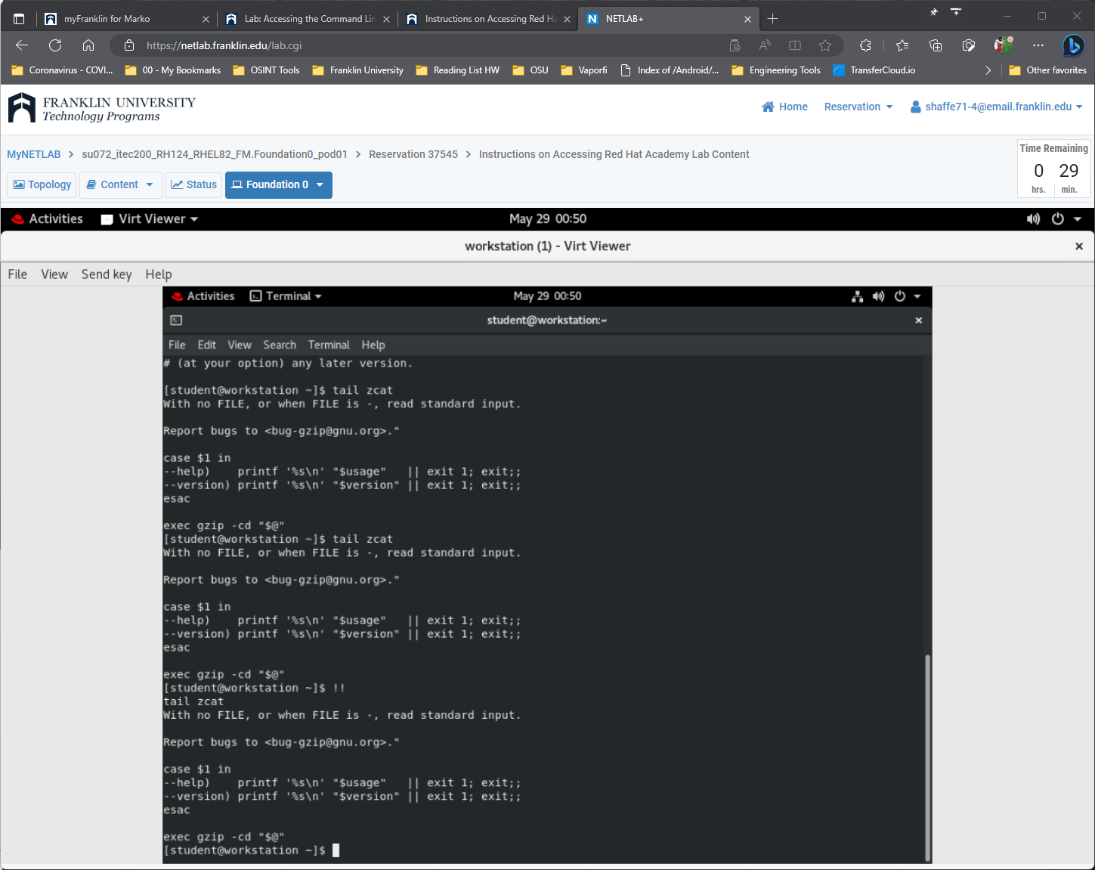

1. Repeat the previous command, but use the -n 20 option to display the last 20 lines in the file. Use command-line editing to accomplish this with a minimal number of keystrokes.

**UpArrow** displays the previous command. **Ctrl**+**A** makes the cursor jump to the beginning of the line. **Ctrl**+**RightArrow** jumps to the next word, then add the -n 20 option and hit **Enter** to execute the command.

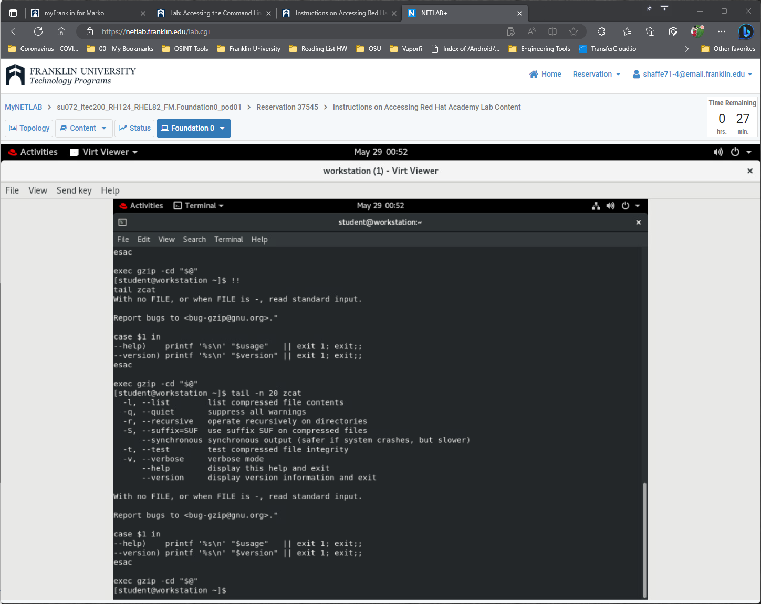

1. Use the shell history to run the **date +%r** command again.

Use the **history** command to display the list of previous commands and to identify the specific **date** command to be executed. Use **!*number*** to run the command, where *number* is the command number to use from the output of the **history** command.

Note that your shell history may be different from the following example. Determine the command number to use based on the output of your own **history** command.

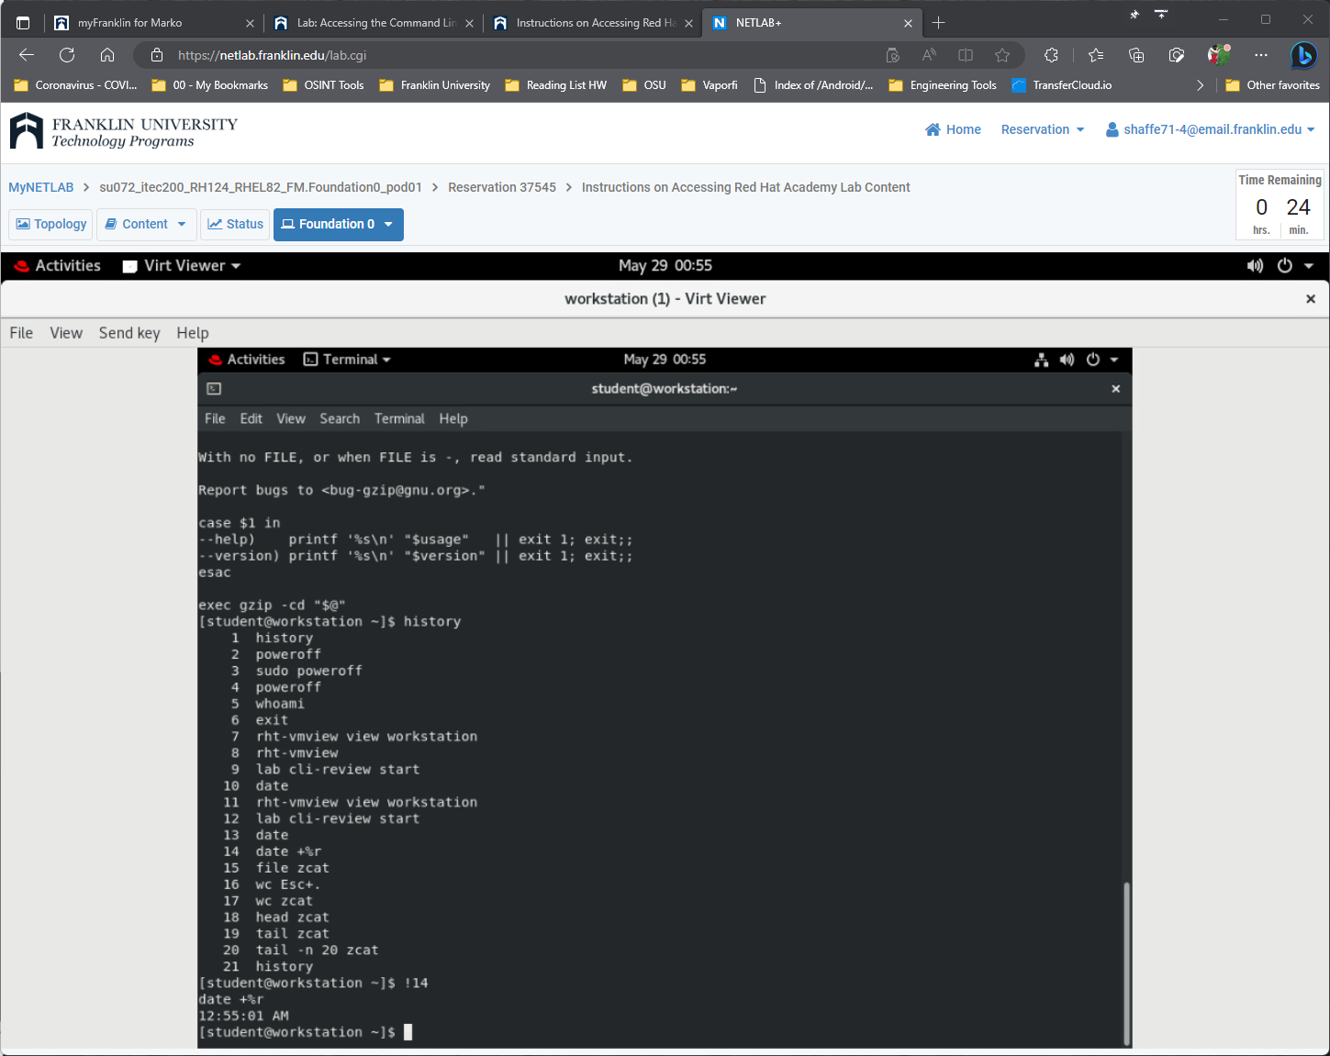

**Evaluation**

On workstation, run the **lab cli-review grade** script to confirm success on this exercise.

**[student@workstation ~]$ lab cli-review grade**

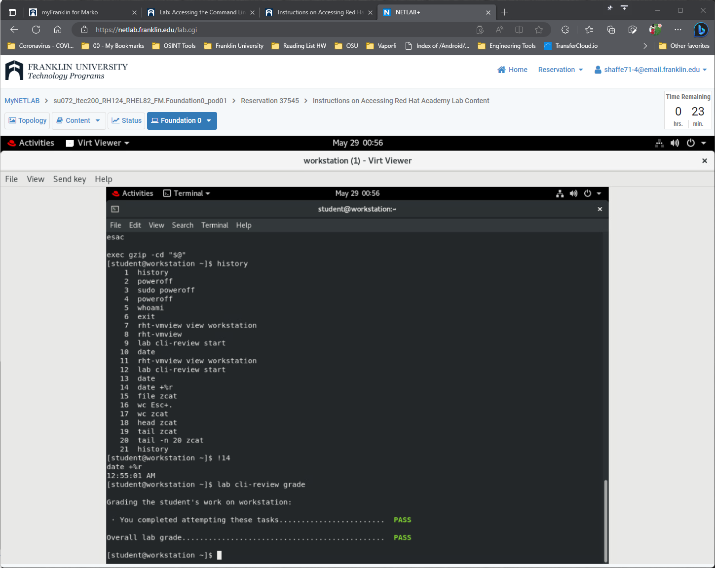

**Finish**

On workstation, run the **lab cli-review finish** script to complete the lab.

**[student@workstation ~]$ lab cli-review finish**

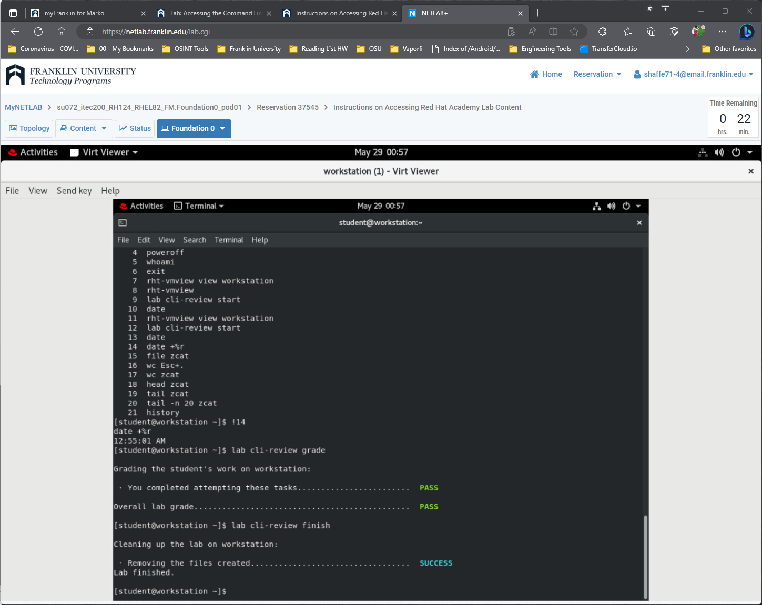

This concludes the lab.